Summer term newsletter number 2 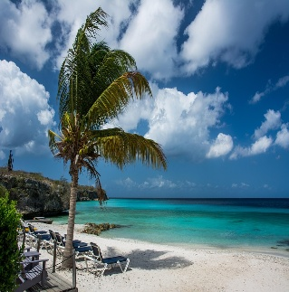
Well it has come to that time of the year when we are preparing the older children for their journey into big school, and the younger children will soon be the older ones. It is always hard to say goodbye to the children as they move onto their next stage in learning but it is also very rewarding to see them thrive at school.
Please remember to bring in a labelled drink bottle to keep at Pre-school so that the children can access a drink whenever they need it especially when it,is hot.
This term we welcome Shane into Pre-school, he has already made himself at home so lets hope that he continues to enjoy his time with us.

During this term we will continue to learn about life cycles and the environment.
The children have enjoyed finding insects in amongst the herb beds and have rescued a few baby snails. We also have a naughty squirrel that comes into our play area and sits on the fence watching the children looking at him, he is quite
a character.
Bottle stall
Pre-school will be holding a bottle stall at this years flower show as it is such a good fundraiser.
We have plenty of empty screw top wine bottles but are in desperate need of full bottles please. Some of you parents have already kindly donated a few bottles but we are going to need lots to make the bottle stall worthwhile.
School visits
We have 4 school visits booked in for this term.
The first visit will be on Wednesday 18th June, this will be a quick 10 minute tour around the classroom, so the school children not attending on Wednesdays do not have to come in for this as I will show them around the classroom on a day that they are in.
Wednesday 25th June will also be a quick visit and tour around the school. July 2nd and 9th the children will go into the class for 9.15am until 10.30am so these are the two dates that all children going to school in September need to be in.
Please drop them off at Pre-school for 9am and collect them from Pre-school at 10.30 am.
Dates for the diary
Friday 27th June-TD Day
Monday 30th June – TD Day
Thursday 17th July – Last day of term at Pre-school
Friday 18th July – End of term party 10am drop off & 1pm collect. No lunch boxes needed as food is supplied
Tuesday 2nd September – Return from summer holidays

